Kei MDK Download and Installation Guide

Revised 2020/06/10

Go to <https://www.keil.com/arm/demo/eval/arm.htm> to apply for the tool download. Fill out the information requested.

You might see this screen. Fill out at least these checkboxes:

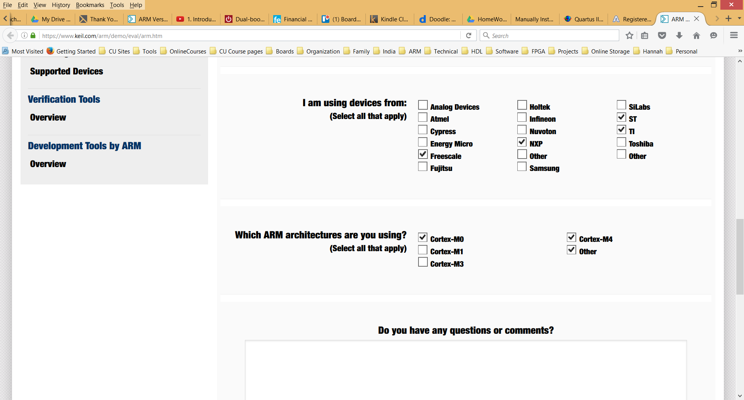

You should then see:

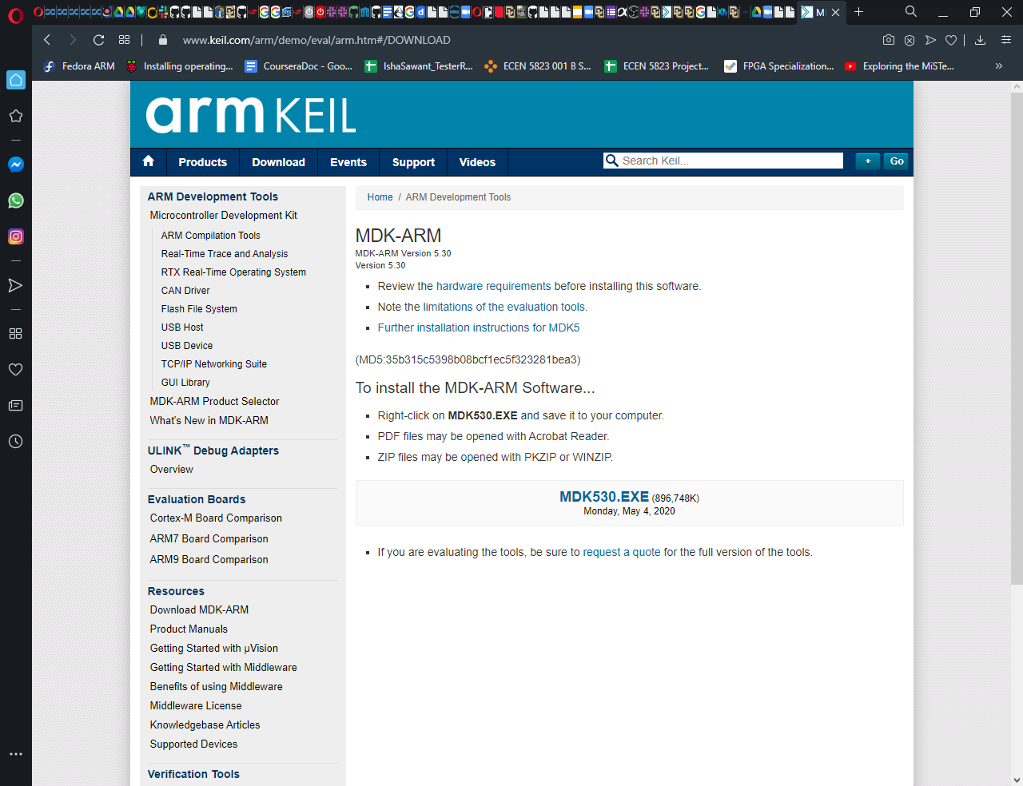

Click on the MDK5xxx.exe to install:

Click on the downloaded .exe file to begin the installation (you may need to run this as an administrator):

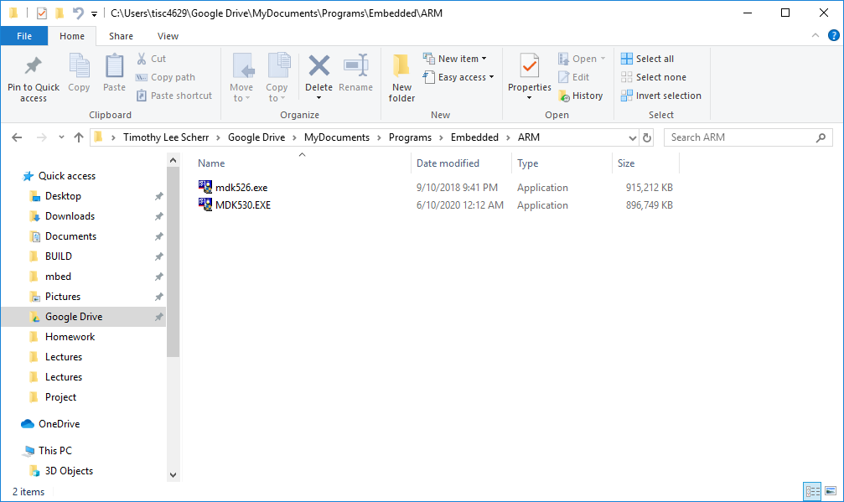

You should see the setup screen:

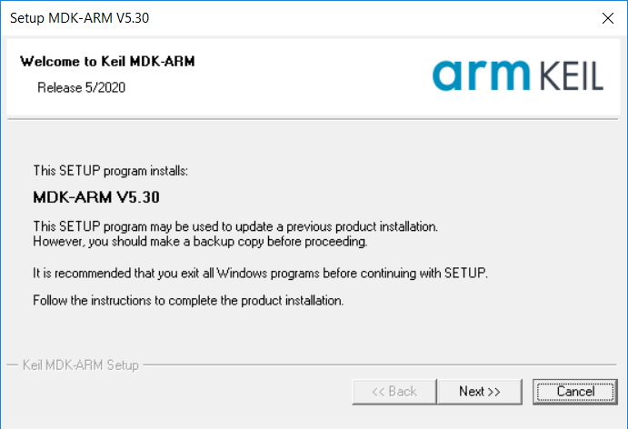

Click through the remaining screen to complete the MDK install. Let it use the default location for the installation. Relax, this may take a while.

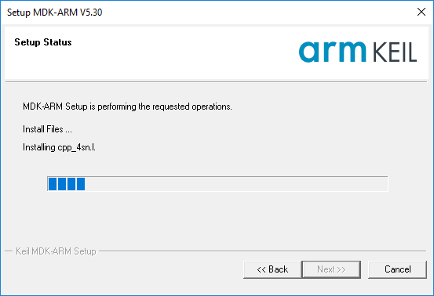

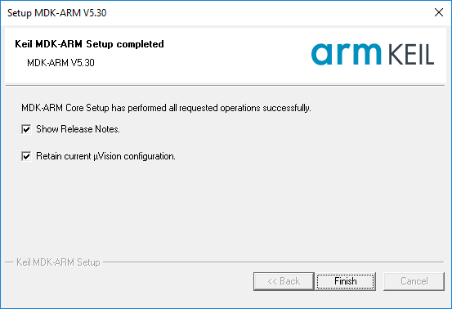

Once this is done, you now need to add software packages for the target processors and boards.

See for more information: <http://www2.keil.com/mdk5/install> The pack installer should automatically appear:

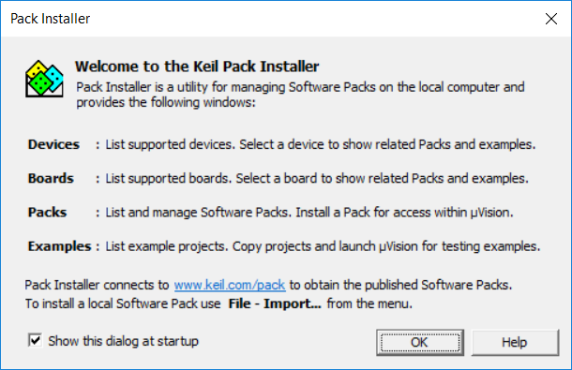

In the pack installer window, click on top menu Packs -> Check for updates. This will fill in all the vendor software packs. You may need to wait several minutes for this to occur.

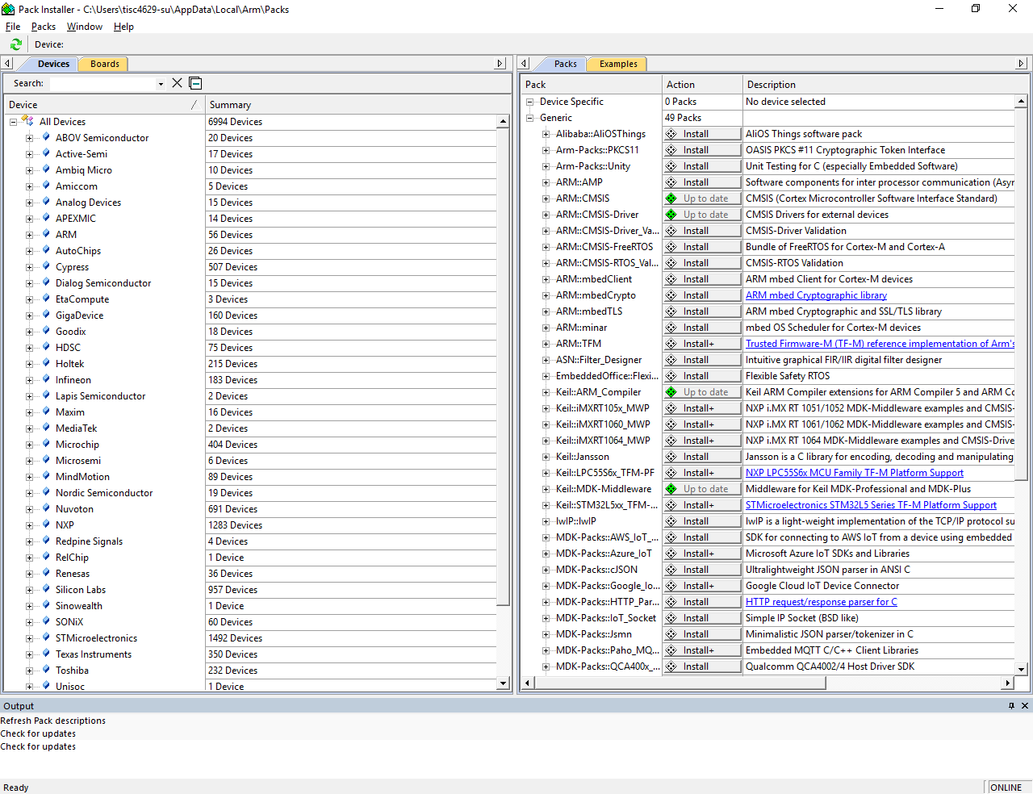

First, under devices select NXP, then the KLXX series, and then KL2x Series:

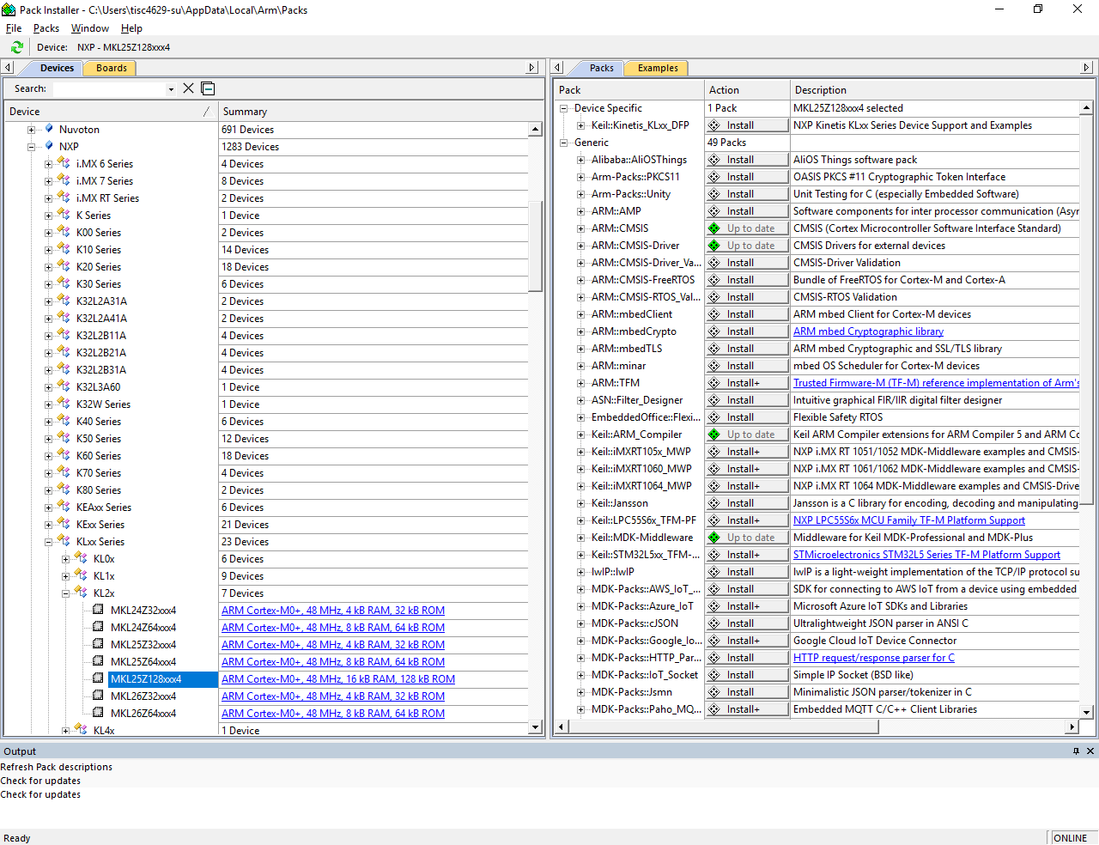

Then select MKL25Z128xxx4, and under packs select Device Specific: Keil Kinetis_KLxx… and install or update this pack. Then under Generic you will need to install and or update all the ARM and Keil::ARM packs as shown below. Do not install Beta versions of the packs. The diamond will turn green after updates are complete.

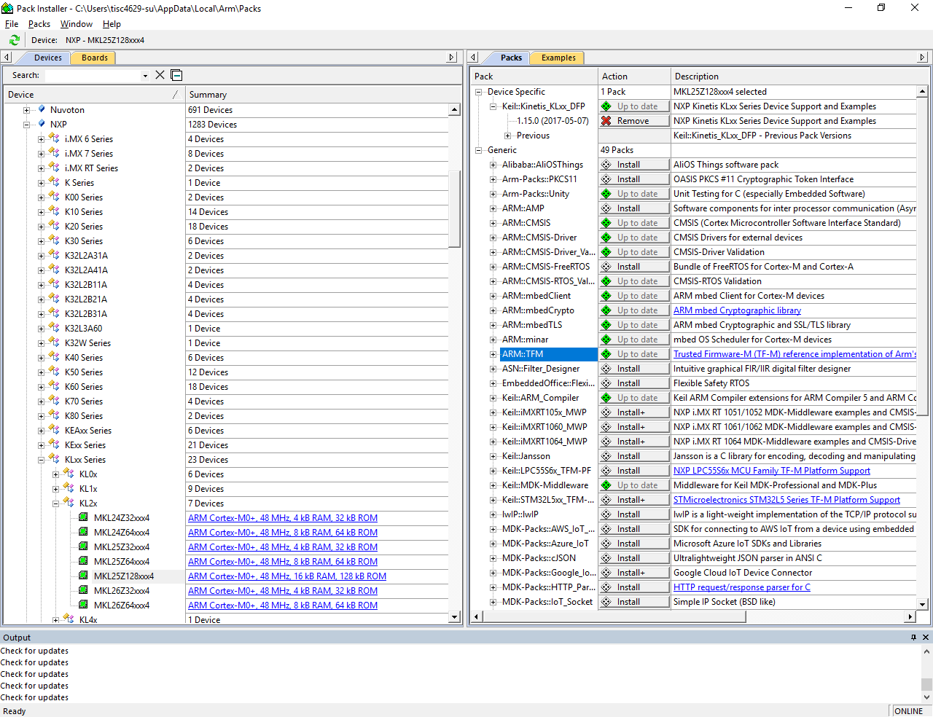

Next, under examples you may want to install the examples listed for this part:

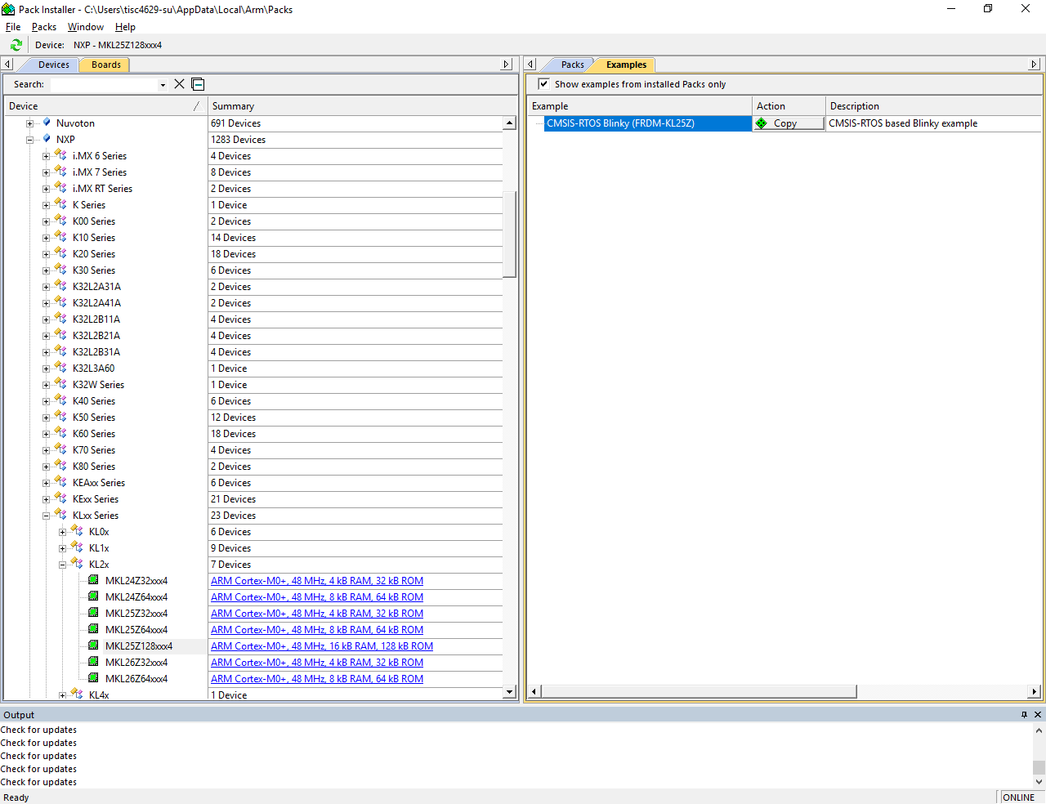

Another approach is to use the board to discover the device. Select the board tab on the upper left, and scroll down to the NUCLEO-401RE where you will find the device is the ST STM32F401RE:

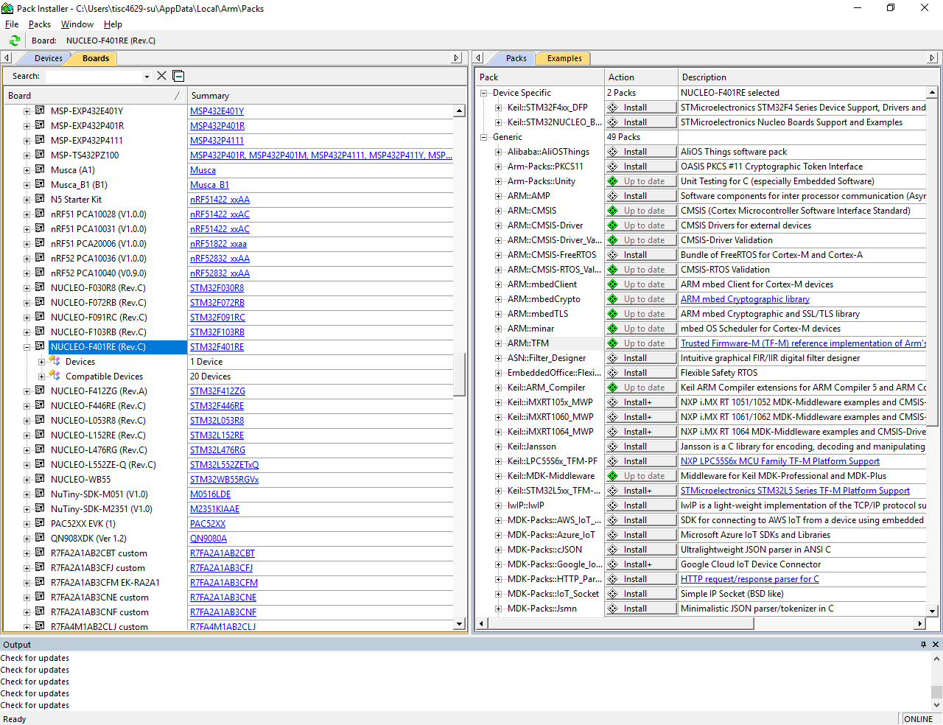

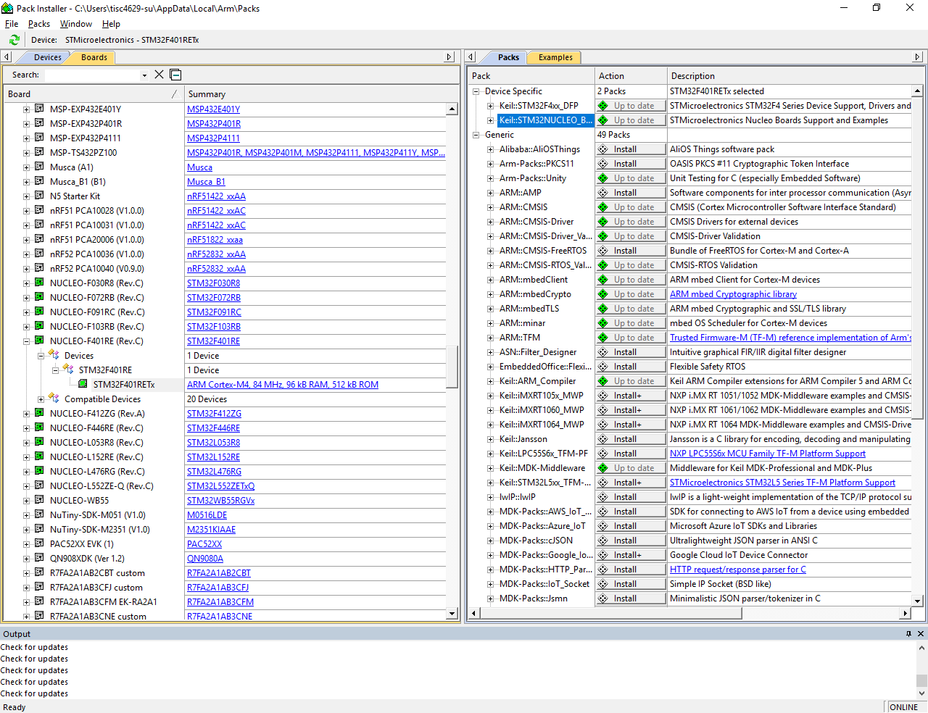

Install all the Device specific packs, the Generic ARM and Keil: ARM_Compiler packs. Also under examples install both the Blinky and CMSIS-RTOS Blinky examples.

Your MDK installation is now complete.

Launch the program by selecting the Keil uVision5 icon.

NOTE: Be sure your machine meets the hardware requirements:

Verify that your computer at least meets the minimum system requirements before you install any Keil software development product.

[MDK](http://www2.keil.com/system-requirements/)

### Minimum Hardware Requirements

* 1 GHz 32-bit or 64-bit processor
* 1 GB of system memory (RAM)
* 2 GB of available disk space

### Recommended Hardware Requirements

* 2+ GHz 64-bit processor
* 4 GB of system memory (RAM)
* 5 GB of available disk space
* 2 Mpbs or higher Internet connection for software activation, product updates and online services like the PackInstaller

### Supported Operating Systems

32-bit and 64-bit variants of Microsoft Windows are supported:

* Windows 10 Home
* Windows 10 Pro
* Windows 10 Enterprise
* Windows 10 Education
* Windows 8.1
* Windows 8.1 Pro
* Windows 8.1 Enterprise
* Windows 8
* Windows 8 Pro
* Windows 8 Enterprise
* Windows 7 Home Basic
* Windows 7 Home Premium
* Windows 7 Professional
* Windows 7 Enterprise
* Windows 7 Ultimate

Linux and Mac are not supported. In that case, you will need to run windows in a virtual box.

Note: Support for 32-bit Microsoft Windows will be **deprecated in Q3/2018**. Please make sure to switch to a 64-bit Microsoft Windows operating system before then.